**Project:** Programming Tutorial Program

**Flowchart:**



**Code:**

// ---------------------------------------------------------------

// Programming Assignment: Course Project

// Developer: Leah Rieger

// Date Written: 07/19/2019

// Purpose: Programming Tutorial Program

// ---------------------------------------------------------------

#include <iostream>

#include <string>

using namespace std;

int main()

{

char ans = 'N';

string userName, letsGo, userAnswer, nextLevel; //declare variables

const string correctAnswer = "string userName;";

cout << "Hello and Welcome to your Programming Tutorial! What is your name? \n";//description of program

std::cin >> userName;

cout << "Call me Brain. \n";

//Here begins the tutorial

cout << "Check this example: \n";

cout << "------------------------------------------------------------------------ \n";

cout << " \n";

cout << "string userName; \n";

cout << "This is how you declare variables. Give it a go? \n";

// A new line character(/n) keeps getting inserted into cin and continuing past the getline (because of a bug where std::cin >> leaves a /n in the cin buffer).

// We use Ignore to clear any previous input.

cin.ignore();

// Get line allows free entry of text up to a delimiter. If one is not specified it defaults to /n.

getline(cin, userAnswer);

//loop to continue when entering a wrong answer

while ((correctAnswer != userAnswer))

{

cout << "Uhoh!! That's not quite it, let's try again. \n";

getline(cin, userAnswer);

};

//Processing, Comparing answers

if (correctAnswer == userAnswer)

{

cout << "WooHoo! Ready for the next one? \n";

system("pause");

}

return 0;

}

**Screenshots:**

**RIGHT ANSWER:**

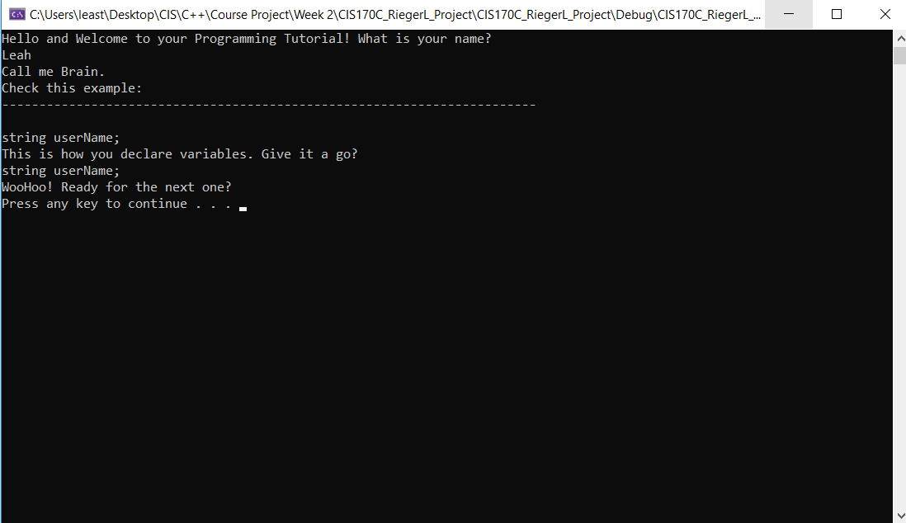

**WRONG ANSWER:**

